Capstone Project - The Battle of Neighborhoods

# Introduction

The first known Chinese restaurant in America, Canton Restaurant, opened in San Francisco in 1849. Today, the cuisine (though much of it bears little resemblance to any dishes you'd find in China) has become a favorite throughout the country, with nearly 50,000 Chinese restaurants across the U.S.

It originally arrived with the flood of Chinese immigrants to California in the mid-nineteenth century—mostly from Canton province—drawn by the Gold Rush and fleeing economic problems and famine in China. By 1880, there more than 100,000 Chinese people living in the U.S; restaurants had begun to crop up to feed the growing population of workers, missing the flavors of home. Of course, the dishes had to be modified to use ingredients that were available in the U.S. to replace those found only in China; they also were tweaked to make them more familiar to American palates. Soon, America faced its own economic downturn, in the 1870s. White workers felt threatened by Chinese laborers, who would work for less money. As a result, the Chinese Exclusion Act, a law forbidding Chinese immigration, was passed in 1882.

An exception was available to a few select groups; starting in 1915, merchants, including high-end restaurateurs, could apply—and many did, exploiting the exception. According to the exhibit, the number of Chinese restaurants in New York City alone quadrupled between 1910 and 1920. Well before that, however, late-1800s versions of hipsters were heading into the city's Chinatown to seek new flavors to satisfy their adventurous palates. They discovered the novel flavors of Americanized Chinese dishes like chop suey and egg foo young, popularizing them to the point that they spread throughout the city. "By 1903," the exhibit says, "over 100 chop suey houses existed between 14th and 45th Streets, from the Bowery to Eighth Avenue." It spread across the nation, reaching a peak in the 1920s and '30s. Meanwhile, the restaurants also went upscale. That merchant visa available to Chinese restaurateurs? It was only for "high grade" restaurants, so the ones that opened featured high-end finishes and gilded carvings; going out for Chinese became a luxury experience.

The Chinese Exclusion Act was repealed in 1943. By that time, the cuisine had entered the mainstream and Chinese restaurants had become ubiquitous. Increased prosperity allowed Americans to dine out more often, and authenticity came into vogue. Classic Americanized dishes like chop suey were abandoned in favor of more-authentic regional Chinese dishes like General Tso's Chicken, invented by a Hunanese chef in the 1950s and brought to the U.S. soon after. Today, the dish is the most-ordered Chinese dish on grubhub.com and the fourth most-popular dish on the website.

In this project, we want to examine a good location to open a Chinese restaurant in New York City, which has a strong Chinese demographic.

# Data and Methodology

To find the best location to open a Chinese restaurant, I use New York City data that contains the latitude and longitude of all neighborhoods in Manhattan. The data is public available: https://cocl.us/new_york_dataset. To have more information on each Chinese restaurant, I use the Foursquare API.

Firstly, the New York City data is downloaded, which includes neighborhood names and geo data. The latitude and longitude can be used to create the map later.

Then I use Foursquare API to query the Chinese restaurant information for each of the neighborhood. The popularity and the rating of the Chinese restaurants in every neighborhood are analyzed. I plot a figure to understand how many Chinese restaurants in each neighborhood in New York. Also, I examine the ranking for tips, ratings, and likes for all Chinese restaurants. Then, I examine the average rating for each neighborhood to see if the local people like Chinese food or not.

Finally I will try to conclude which is the best location to open a new Chinese restaurant based on the data on hand.

# Restaurant Data Analysis

## Data

The first step of the project is to use the function to get the geographical data of the neighborhoods in New York City. The head of results are displayed below.

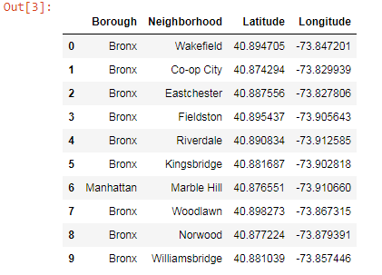

The next step is to build the function to get the Chinese restaurant ID and names in neighborhood using Foursquare API. Then we use the function to get the Chinese restaurant ID and names in each borough. The results are shown below.

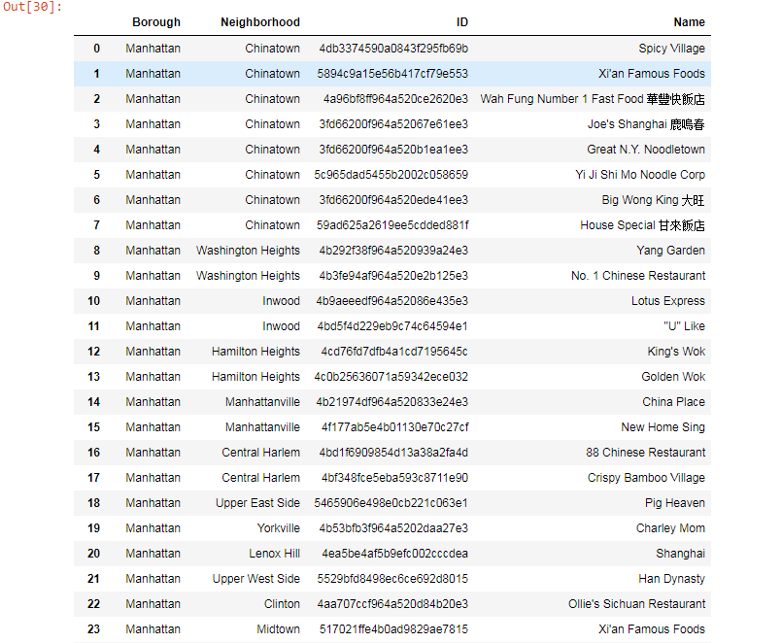

Then we plot the number of Chinese restaurants in each neighborhood. China Town has most Chinese restaurants which is eight, while Bensonhurst, Flushing and Little Neck has five.

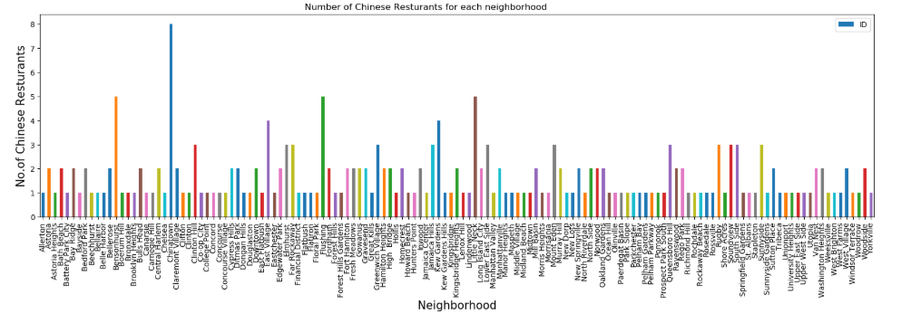

Then we build the function to get the restaurant stats in New York City using Foursquare API. The stats of 'ID', 'Name', 'Likes', 'Rating' and 'Tips' are downloaded.

The head of raw data is shown below. Notice there are some invalid records where Foursquare did not return any data, so they are removed.

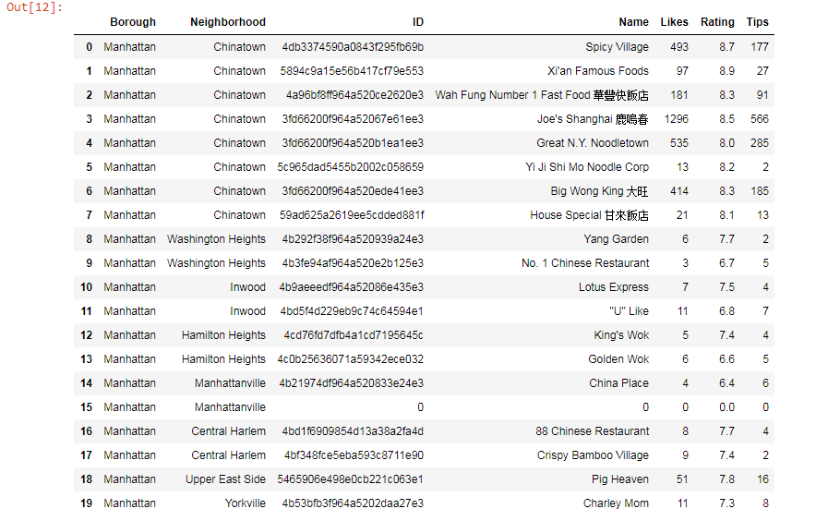

Then we sort the data to find the most popular Chinese restaurant in New York City with most likes.

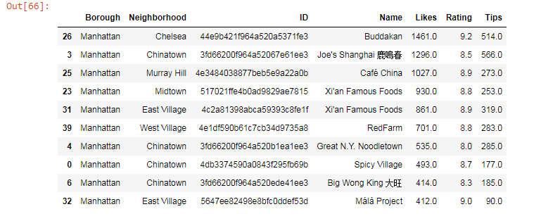

So Buddakan, Joe's Shanghai, Cafe China and two Xi'an Famous Foods are the five most popular Chinese restaurants in New York.

Then try to find Chinese restaurants with highest quality.

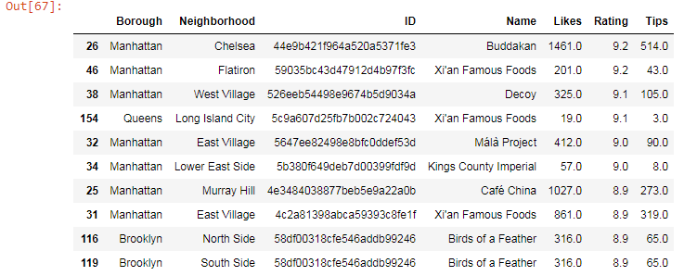

Buddakan, Xi'an Famous Foods, Decoy and Málà Project have highest ratings.

## Summary

If we look the top 10 of both ratings, Buddakan, Xi'an Famous Foods, Málà Project are in both lists.

We can see the location of the restaurant is very important. For Example, Xi'an Famous Foods in Flatiron has rating of 9.2, but only has 201 likes and 43 tips. In comparison with Joe's Shanghai in China Town, even the rating is 8.5, it has 1296 likes and 566 tips.

We can also notice Shanghai cuisine, Xi'an cuisine and Sichuan cuisine is quite popular in New York. Joe's Shanghai offers Shanghai cuisine; Xi'an Famous Foods offers Xi'an cuisine, while Spicy Village and Málà Project offer Sichuan Cuisine. So if we want to open a Chinese restaurant in New York, we can consider there three cuisines.

# Neighborhood Data Analysis

## Data

In next step, let's see the Chinese restaurant stats in each neighborhood. We average the Likes, Rating and Tips of the Chinese restaurants for each neighborhood. Then sort the data.

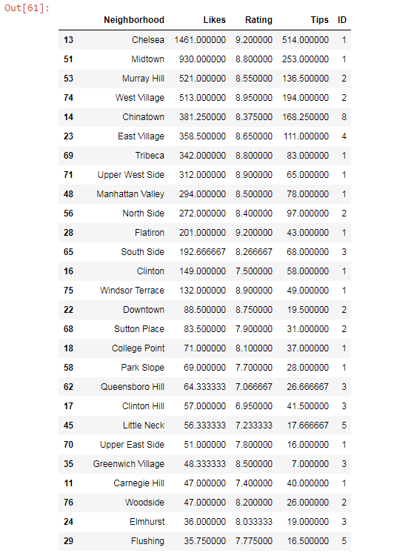

Now we can see the average likes, rating and tips in each neighborhood.

## Summary

Chelsea has the only Chinese restaurant Buddakan which is the top Chinese restaurant in New York, so it has highest number of likes, rating and tips.

Midtown has another good Chinese restaurant Xi'an Famous Food, so it has second highest number of likes.

The Chinese restaurants in Murray Hill, West Village, Chinatown and East Village are also quite popular in average. So to open a new Chinese restaurant, we can consider these areas based on the data we have.

Then we look into the data for these neighborhoods.

### Chinatown

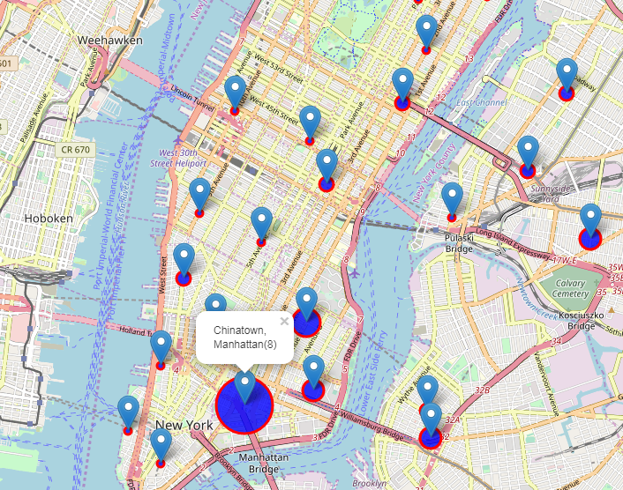

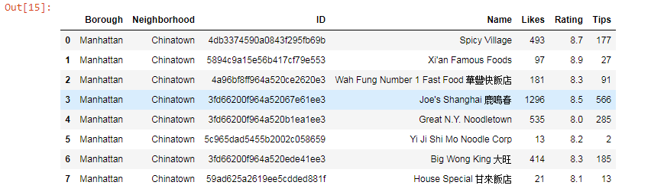

There are eight Chinese restaurants in Chinatown, which makes the neighborhood competitive. Three of them are good restaurants: Joe's Shanghai has 1296 likes, Xi'an Famous Food has 8.9 rating, Spicy Village has 8.7 rating. So we need careful consideration if want to open a another Chinese restaurant in Chinatown.

### East Village

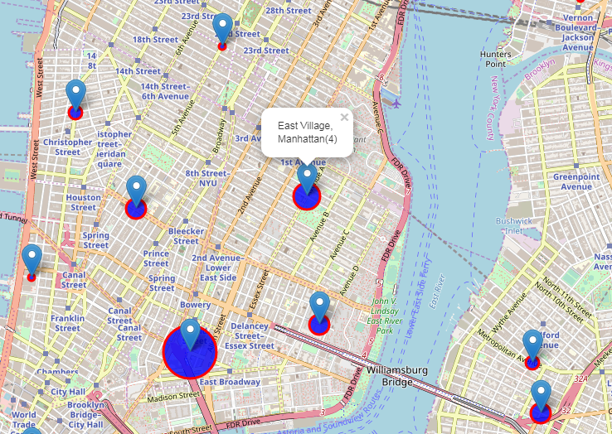

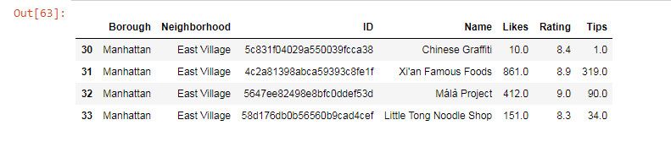

There are four Chinese restaurants in East Village. Two of them are good restaurants: Xi'an Famous Food has 8.9 rating and 861 likes; Málà Project has 9.0 rating and 412 likes. So if we want to open a Chinese restaurant here, we can try to open a Shanghai cuisine restaurant.

### Murray Hill

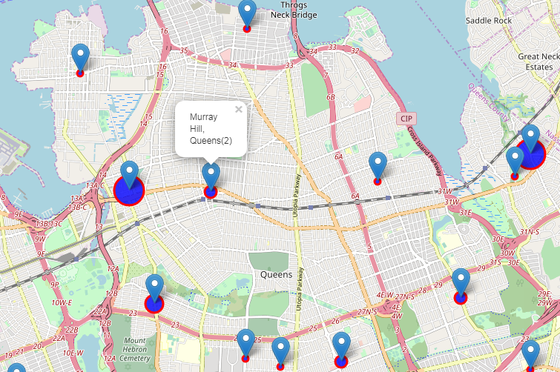

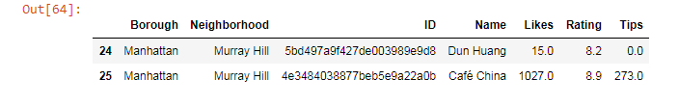

There are two Chinese restaurants in Murray Hill. Café China has 8.9 rating and 1027 likes. So we can try to open a Shanghai cuisine, Xi'an cuisine or Sichuan cuisine restaurant here.

### West Village

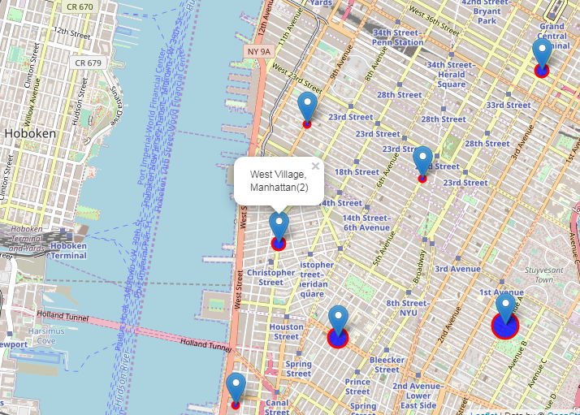

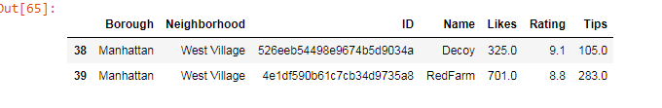

There are also two Chinese restaurants in West Village. Both of them have high ratings, which makes the neighborhood competitive. However, neither of them belongs to Shanghai cuisine, Xi'an cuisine or Sichuan cuisine, so we can also try to open one restaurant here.

# Conclusion

By analyzing the data we have, we can find that the Chinese restaurants in Murray Hill, West Village, and East Village are popular in average; also these neighborhoods are not so competitive comparing with Chinatown for Chinese restaurants. Also Shanghai cuisine, Xi'an cuisine and Sichuan cuisine are popular in New York, because many top Chinese restaurants offers these cuisines. Finally, we can consider opening a Shanghai cuisine restaurant in East Village, or opening a Shanghai cuisine, Xi'an cuisine or Sichuan cuisine in Murray Hill or West Village.